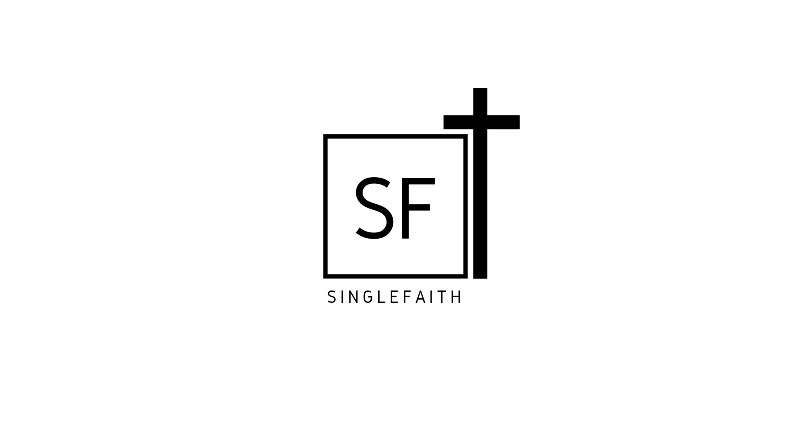

SINGLEFAITH

Christian Singles

Long Weekend Getaway

3 nights

Aug 30, 2019 to Sept 2, 2019

Bedford, PA

Come away from the daily grind for a weekend of relaxation and refreshment and fun with other Christian Singles!
The 2019 Singlefaith Long Weekend Getaway will be held from August 30th to September 2nd - 3 nights - at the unique and historic Harrison House near Bedford, Pennsylvania.
http://www.whitesulphursprings.org/harrison-house/
Address: 4500 Milligans Cove Rd, Manns Choice, PA 15550
https://goo.gl/maps/hf2xBh2k8eEJ2ips5
Some improvements this year over 2017 and 2018 - we have the entire Harrison House to ourselves and we are not subject to a fixed dining room schedule, allowing us a lot of freedom and flexibility for making this a really great weekend trip!
Cost includes all meals from Friday evening through Monday lunch and 3 nights lodging.
$275.00 per person for double occupancy bedroom (separate beds sharing a room)
$350.00 for a private bedroom (may or may not be a private bathroom, see notes below)
REFUND Policy: 75% refund if canceled before August 16. No refunds after August 16.
TO MAKE A RESERVATION: email Michelle at michelle.meetup.md@gmail.com for instructions
If you need a payment plan or to pay a little bit each month, contact Michelle and she will work with you.

Notes:

1. No rooms in this unique, historic building are the same configuration. Some bedrooms have a full bathroom within the room, other bedrooms have a full bathroom just outside the room, still others have what is called a jack-and-jill bathroom between 2 rooms. Two or Three private bedrooms (for example) may share a full bathroom. A private bedroom and a double occupancy bedroom may share a full bathroom between them.
2. There are no elevators. 2nd floor rooms will be given priority to anyone who has limited ability to use stairs. 3rd floor rooms are really not that bad of a climb (in Michelle's opinion).
3. There are a few 'party rooms' which will each sleep 4 or 5 in separate beds. If a group of friends would like to room together in this arrangement, please contact Michelle. They are nice rooms. :-)

This year there will be a time of instruction and encouragement from Noah Kaye, founder of Integer Network.
https://www.integernetwork.com/
Integer's values - Jesus, Integrity, Wholeness, Authenticity, Journey, Partnership
https://www.integernetwork.com/values
Stay tuned for more details on what Noah will be teaching us.

There will be A LOT of time for fun and recreation:
Canoeing and Kayaking, Hiking, a really cool 120 year old bowling alley (that you need to see to believe), Campfire time each evening, and excursions to nearby Bedford, PA, potentially even some horseback riding and target shooting.
http://www.whitesulphursprings.org/activities/
http://www.visitbedfordcounty.com/

Map of hiking trails on site: http://www.whitesulphursprings.org/wp-content/uploads/sites/5/2018/09/Hiking-Trail-Map.pdf

Photos of the accommodations:
https://drive.google.com/open?id=1QNxl08S0tw2u3__8_Qfv3JXx0U19a8eB

